PRODUCT INFORMATION
Product Name: Ceekay’s Hot ‘n’ Spicy Marinated Wings (35-45g) 6x1Kg
Description: Coated prime chicken wings with hot’n’spicy marinade
NAME AND ADDRESS OF PROCESSOR

Name: CK Foods (Processing) Ltd
Health Mark: UK VY073 EC
Address: St. Dunstans Way, off Ripley Street, West Bowling, Bradford, West Yorkshire, BD4 7HH, UK
Contact: CK Foods (Processing) Ltd.
70 Northumberland Avenue
Hull, East Yorkshire HU2 0JB
England, UK
Tel: 0044 (0)1482 589961
Fax: 0044 (0)1482 222776 Email: info@ck-foods.com
INGREDIENTS

Chicken (78.7%), Water, Salt, Flavour Enhancer (Monosodium Glutamate E621), Stabiliser (Triphosphates E451), Potato Starch, Garlic Powder, Spices (Cayenne, White Pepper, Black Pepper), Potato Maltodextrin, Capsicum Extract, Spice Extracts (Capsicum Extract & Black Pepper Extract), Vegetable Oil (Rape), Thickener (Xanthan Gum E415).
Allergen information is shown in BOLD CAPITALS.
WARNING: PRODUCT CONTAINS BONES
NUTRITIONAL INFORMATION

 |  |  | Typical values per 100g |  | Typical Per serving (120g)
 | Energy |  | 654kj/157kcal |  | 784KJ/188.4Kcal
 | Fat |  | 8.9 |  | 10.68
 | -of which saturates |  | 2.4 |  | 2.88
 | Carbohydrates |  | 1.3 |  | 1.56
 | -of which sugars |  | <0.1 |  | 0.12
 | Fibre |  | 0.6 |  | 0.72
 | Protein |  | 18.0 |  | 21.6
 | Salt |  | 3.24 |  | 3.89
ENERGY (KJ/Kcal)  784kj/188kcal  9% |  | Fat  10.7g  15% |  | Saturates  2.9g  14% |  | Sugars  0.1g  <1% | Salt  3.9g  65%
PACKAGING DETAILS

Pack size | Batch Details | Box dimension (L x W x H) | Bag Dimension (H x W x D) | Labelling  (Bag) | Product code on  the Bag | Bag barcode | Tape colour | Labelling  (Box) | Product code on  the Box | Box barcode
6 x 1kg | PD: DD/MM/YYYY  BB: DD/MM/YYYY  BATCH CODE: JULIAN CODE  TIME: HH:MM | 384mmx 250mm  x 174mm | 285mm x 270mm x 45mm | 140mm x140mm Colour Printed Label | CK09D2 | 5055973203946 | Top (LB)  Bottom (Clear) | 220mm X 78mm  Inkjet details on to box label | CK09DD2 | 5055973213150

Product Image
Bag label

Halal

Ingredients and allergen information
Cooking Instructions

Storage Information
Nutritional Information

Suppliers address

Barcode

Health mark
\\\Sup

Health mark
Product Name

Box label

Production details

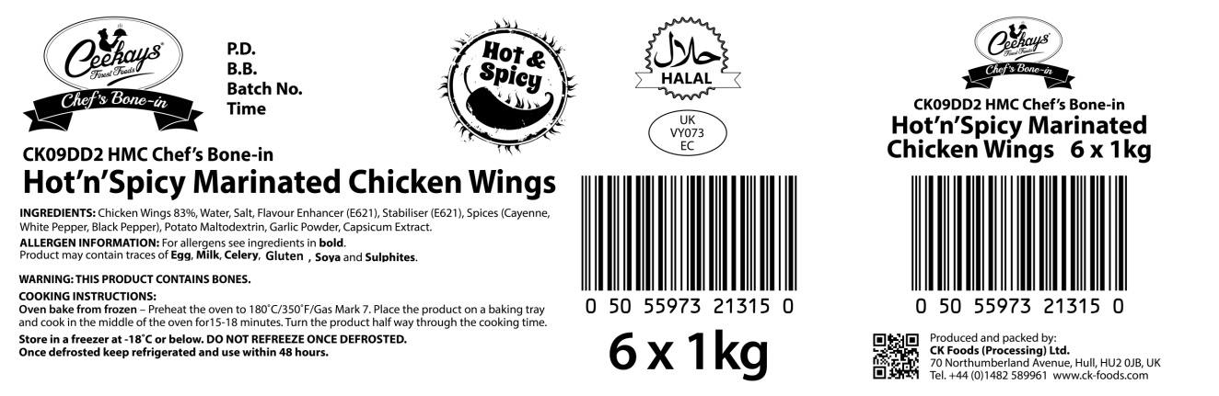
Product Code

Product name

Ingredients and allergen information

Health mark

Barcode
Box quantity and pack size

STORAGE INSTRUCTIONS
Store in a freezer at -18ᵒC or below. DO NOT REFREEZE ONCE DEFROSTED. Once defrosted keep refrigerated and use within 48 hours
PRODUCT SHELF-LIFE
18 months from the date of manufacturing (frozen)
COOKING INSTRUCTIONS
Oven bake from frozen – Oven bake from frozen – Preheat the oven to 180ᵒC. Place the product on baking tray and cook in the middle of the oven for 15-18 minutes. Turn the product half way through the cooking time.
ALLERGEN INFORMATION

Egg | No | Milk | NO | Sesame seed | Absent
Celery | No | Mustard | Absent | Fish | Absent
Soybean | Absent | Nuts | Absent | Molluscs | Absent
Gluten | No | Crustaceans | Absent | Lupin | Absent
Sulphur dioxide and sulphite | No | Peanuts | Absent

IMPORTANT: MAY CONTAIN EGG, MILK, CELERY, GLUTEN, SULPHUR DIOXIDE AND SULPHITES
HACCP

There is a documented HACCP system in place at the site which is fully implemented to ensure that potential food safety risks are minimised. The HACCP system includes the analysis of chemical, physical, microbiological and allergenic risks from raw material procurement through the whole process to dispatch to the customer.
ORGANISM | TARGET | MAXIMUM
TVC | < 10000 | <1 x 10⁵
Salmonella | Absent in 25g | None
Campylobacter | Absent in 25g | None
Listeria Spp | Absent in 25g | None
MICRO ANALYSIS

PALLET CONFIGURATION
Pallet configuration
100 boxes/  pallet | 10 boxes/layer | 10 layers
DIETARY
Lacto-Ovo- Vegetarian | Vegan | Halal
NO | NO | YES (HMC)
ORGANOLEPTIC CHARACTERISTICS
Colour & Appearance: Deep Orange in colour
Taste & Flavour: Succulent chicken wings in a Hot & Spicy marinade
*Private and confidential
**Specifications are subject to change

Authorised by (print) | Omar Bhamji |  | Approved by (print)
Sign  (Managing Director  CK Foods Processing Ltd) |  |  | Sign
 |  |  | For company
Date | 29/04/19 |  | Date

