PRODUCT INFORMATION
Product Name: Peri Peri Breaded Mini Fillets (45-55g) 12X500g
Description: Citrus Flavoured breadcrumb coated chicken breast mini fillets with a subtle hint of heat.
NAME AND ADDRESS OF PROCESSOR
Name: CK Foods (Processing) Ltd
Health Mark: UK VY073 EC
Address: St. Dunstans Way, off Ripley Street, West Bowling, Bradford, West Yorkshire, BD4 7HH, UK
Contact: CK Foods (Processing) Ltd.
70 Northumberland Avenue
Hull, East Yorkshire HU2 0JB
England, UK
Tel: 0044 (0)1482 589961
Fax: 0044 (0)1482 222776
Email: technical@ck-foods.com
INGREDIENTS
Chicken Breast Fillet (61%), Water, WHEAT Flour, WHEAT Semolina, Rapeseed Oil, Flavour Enhancer: E621, Maize Starch, WHEAT Starch, WHEAT Gluten, Salt Breadcrumb (WHEAT Flour, Yeast, Salt), Stabilisers (E451, E450, E407), Gram Flour, Flavouring, Lemon Oil, Maltodextrin, Capsicum Extract, Paprika Powder, Pepper, EGG Albumen, Cayenne Pepper, Raising Agents (E450(i), E500(ii)), Herb, Black Pepper Extract, Garlic Powder, Sodium Diacetate :E262, Coriander, Oregano, Citric Acid: E330, Anti-caking Agent: (E551), Colour: E100.
Allergen information is shown in BOLD CAPITALS.
WARNING: ALTHOUGH GREAT CARE HAS BEEN TAKEN TO REMOVE ALL BONES, SOME TRACES MAY STILL REMAIN.
NUTRITIONAL INFORMATION
 | Typical values per 100g | Typical values per serving (150g) - 3 Pieces
Energy | 1042kj/249kcal | 1563kj/373.5kcal
Fat | 13.6 | 20.4
-of which saturates | 1.4 | 2.1
Carbohydrates | 13.4 | 20.1
-of which sugars | 0.2 | 0.3
Fibre | 2.0 | 3.0
Protein | 19.5 | 29.3
Salt | 2.47 | 3.7

PER 3 MINI FILLETS (150g) SERVING CONTAINS:
ENERGY (KJ/Kcal)  1563kj/373.5kcal  19% | Fat  20.4g  29% | Saturates  2.1g  11% | Sugars  0.3g  <1% | Salt  3.7g  62%

PACKAGING DETAILS

Pack size | Batch Details | Box Dimension  (L x W x H) | Bag Dimension  (H x W x D) | Labelling | Product Code on the Bag | Bag Barcode | Product Code on the Box | Box Barcode
12 x 500g | PD: DD/MM/YYYY  BB: DD/MM/YYYY  BATCH CODE:  JULIAN CODE  TIME: HH:MM | 384mm x 249mm x 194mm | 240mm x 270mm x 45mm | 110mmx110mm Bag Label. Inkjet details on to box label | CK01AE5 | 5055973210579 | CK01AE5 | 05055973210586

Product Image
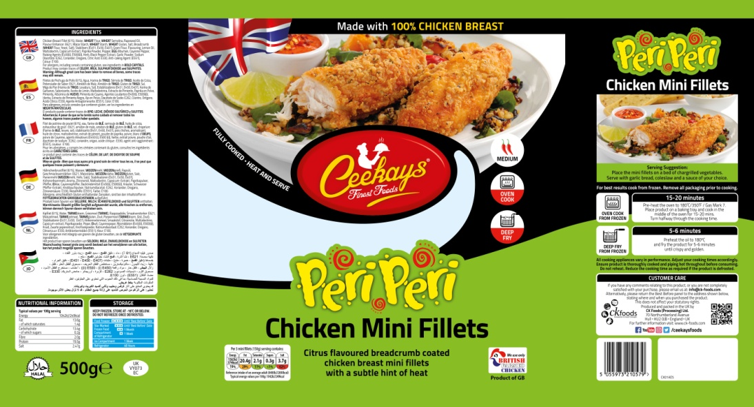
Bag label
Ingredients

Cooking Instructions

Storage Information

Supplier address

Halal
Barcode
Product name
Nutritional Information
Health mark
Pack weight

Box label

Product Code
Product name
Production Details
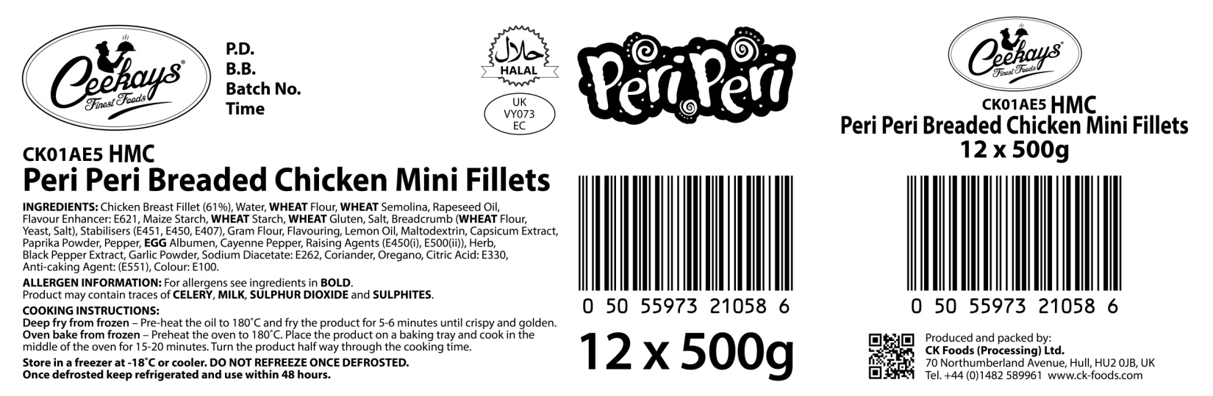
Barcode
Box quantity and pack size
Health mark
Ingredients and allergen information

STORAGE INSTRUCTIONS
Store frozen at temperature -18ᵒC or below Do not refreeze once defrosted. Once defrosted keep refrigerated and use within 48 hours.
PRODUCT SHELF-LIFE
18 months from the date of manufacturing (frozen)
COOKING INSTRUCTIONS
Deep fry from frozen – Pre-heat the oil to 180ᵒC and fry the product for 5-6 minutes until crispy and golden
Oven bake from frozen – Preheat the oven to 180ᵒC/350°F/Gas mark. Place the product on baking tray and cook in the middle of the oven for 15-20 minutes. Turn the product half way through the cooking time.
ALLERGEN INFORMATION
Egg | YES | Milk | NO | Sesame seed | Absent
Celery | No | Mustard | Absent | Fish | Absent
Soya | Absent | Nuts | Absent | Molluscs | Absent
Gluten | Yes | Crustaceans | Absent | Lupin | Absent
Sulphur dioxide and sulphite | No | Peanuts | Absent
IMPORTANT: MAY CONTAIN CELERY, MILK, SULPHUR DIOXIDE AND SULPHITES.
HACCP
There is a documented HACCP system in place at the site which is fully implemented to ensure that potential food safety risks are minimised. The HACCP system includes the analysis of chemical, physical, microbiological and allergenic risks from raw material procurement through the whole process to dispatch to the customer.
PALLET CONFIGURATION
Pallet configuration
90 boxes/pallet | 10 boxes/layer | 9 layers
DIETARY
Lacto-Ovo- Vegetarian | Vegan | Halal
NO | NO | YES (HMC)
ORGANOLEPTIC CHARACTERISTICS
Colour and Appearance: Deep orange in colour
Taste and Flavour: Succulent chicken breast coated in crispy crunchy peri-peri coating

*Private and confidential
**Specifications are subject to change
Authorised by (print) | Omar Bhamji |  | Approved by (print)
Sign  (Managing Director  CK Foods Processing Ltd) |  |  | Sign
 |  |  | For company
Date | 02/07/19 |  | Date

