PRODUCT INFORMATION
Product Name: Ceekays Smoky BBQ Marinated Chicken Wings
Description: Coated Prime Chicken Wings with a smoke infused savoury and sweet marinade
NAME AND ADDRESS OF PROCESSOR
Name: CK Foods (Processing) Ltd
Health Mark: UK VY073
Address: St. Dunstans Way, off Ripley Street, West Bowling, Bradford, West Yorkshire, BD4 7HH, UK
Contact: CK Foods (Processing) Ltd.
70 Northumberland Avenue
Hull, East Yorkshire HU2 0JB
England, UK
Tel: 0044 (0)1482 589961
Fax: 0044 (0)1482 222776 Email: info@ck-foods.com
INGREDIENTS
Chicken (82%) , Water, Salt, Fortified WHEAT Flour (With Calcium, Iron, Niacin &Thiamine), Sugar, Stabilisers (Diphosphate E450), Maltodextrin, Rusk (Fortified WHEAT Flour [With Calcium, Iron, Niacin &Thiamine]), Flavour Enhancer (Monosodium Glutamate E621), Smoked Salt, Spice Extracts, Starch (WHEAT), Spices, Acidity Regulator (Sodium Diacetate E262), Herb Extract, Malt Extract (BARLEY), Dried Onion, Herb, Dried Tomato, Yeast Extract (SULPHITE), Colour (Paprika Extract E160C), Natural Flavouring
Allergen information is shown in BOLD CAPITALS
NUTRITIONAL INFORMATION
 | Typical values per 100g | Typical values per serving - 3 wings (120g)
Energy | 693kj/166kcal | 831.6kj/199.2lcal
Fat | 9.4g | 11.28g
-of which saturates | 2.5g | 3.0g
Carbohydrates | 1.6g | 1.92g
-of which sugars | 0.6g | 0.72g
Fibre | 0.7g | 0.84g
Protein | 19.1g | 23.3g
Salt | 1.6g | 1.92g

Per serving - 3 wings (120g)
ENERGY (KJ/Kcal)  831.6kj/199.2lcal  10% | Fat  11.28g  16% | Saturates  3.0g  15% | Sugars  0.72g  <1% | Salt  1.92g  32%

Pack size | Type | Pallet configuration |  |  | Box dimension (L x W x H) | Bag Dimensions (L x W x H) | Labelling | Bag barcode | Box barcode
10 x 600g | HMC | 90  boxes/pallet | 10  boxes/ layer | 9  layers | 384mm x 249mm x 194mm | 250mm x 270mm x 45mm | 140mmx140mm Bag Label. Inkjet details on to box label | 5055973211897 | 05055973211903
PACKAGING DETAILS

Product Image
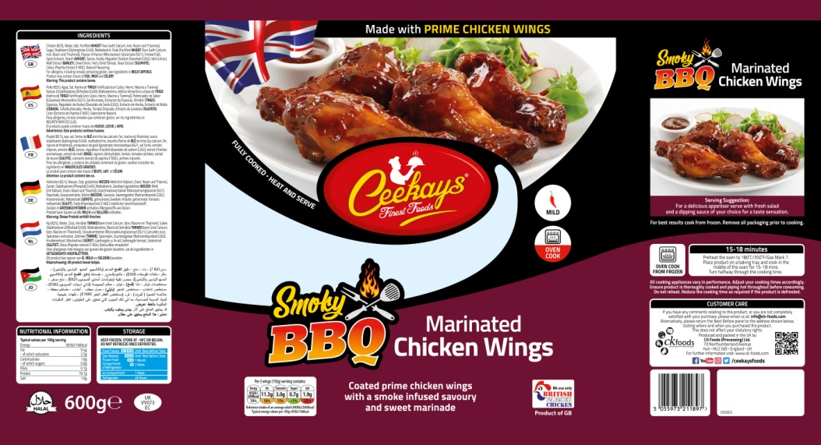
Bag Label
Ingredients

Cooking Instructions
Storage Information
Supplier address

Halal
Barcode
Product name
Health mark
Pack size

Box label
Product code
Production details
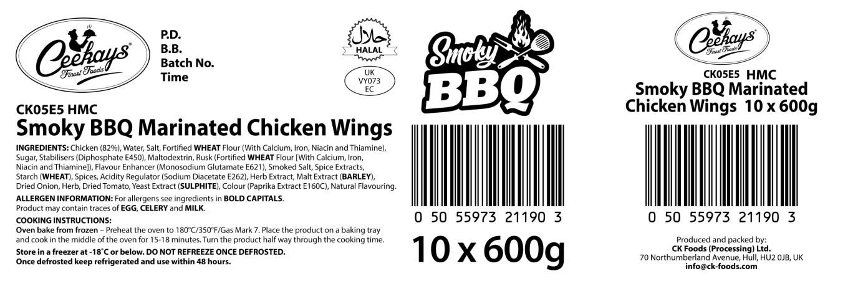
s
Product name

Ingredients and allergen information
Barcode

Health mark
Box quantity and pack size

STORAGE INSTRUCTIONS
Store in a freezer at -18ᵒC or below. DO NOT REFREEZE ONCE DEFROSTED. Once defrosted keep refrigerated and use within 48 hours
PRODUCT SHELF-LIFE
18 months from the date of manufacturing (frozen)
COOKING INSTRUCTIONS
Oven bake from frozen – Oven bake from frozen – Preheat the oven to 180ᵒC/350°F/Gas mark 7. Place the product on baking tray and cook in the middle of the oven for 15-18 minutes. Turn the product half way through the cooking time.
ALLERGEN INFORMATION
Egg | No | Milk | NO | Sesame seed | Absent
Celery | No | Mustard | Absent | Fish | Absent
Soya | Absent | Nuts | Absent | Molluscs | Absent
Gluten | yes | Crustaceans | Absent | Lupin | Absent
Sulphur dioxide and sulphite | Yes | Peanuts | Absent
MAY CONTAIN EGG, CELERY AND MILK
HACCP
There is a documented HACCP system in place at the site which is fully implemented to ensure that potential food safety risks are minimised. The HACCP system includes the analysis of chemical, physical, microbiological and allergenic risks from raw material procurement through the whole process to dispatch to the customer.
DIETARY
Lacto-ovo-vegetarian: NO
Vegan: NO
ORGANOLEPTIC CHARACTERISTICS
Colour and Appearance: Golden brown
Taste and Flavour: Succulent chicken wings in a BBQ coating
*Private and confidential
**Specifications are subject to change
Authorised by (print) | Omar Bhamji |  | Approved by (print)
Sign  (Managing Director  CK Foods Processing Ltd) |  |  | Sign
 |  |  | For company
Date | 29/04/19 |  | Date

