PRODUCT INFORMATION
Product Name: Chef’s Classic Crispy Breaded Chicken Nuggets
Description: Succulent chopped and shaped chicken breast coated in crunchy golden lightly seasoned breadcrumbs
NAME AND ADDRESS OF PROCESSOR
Name: CK Foods (Processing) Ltd
Health Mark: UK VY073 EC
Address: St. Dunstans Way, off Ripley Street, West Bowling, Bradford, West Yorkshire, BD4 7EG, UK
Contact: CK Foods (Processing) Ltd.
70 Northumberland Avenue
Hull, East Yorkshire HU2 0JB
England, UK
Tel: 0044 (0)1482 589961
Fax: 0044 (0)1482 222776
Email: info@ck-foods.com & technical@ck-foods.com
INGREDIENTS
Chicken Breast Fillet (59%) Water, WHEAT Breadcrumb (WHEAT Flour, Salt, Yeast), WHEAT Semolina, Rapeseed Oil, WHEAT Flour, Gram Flour, Cornflakes (Maize, Sugar, Salt, BARLEY, Malt Extract), WHEAT Gluten, Salt, Maize Starch, Dried onion, Monosodium Glutamate, Yeast Extract (SULPHITES), EGG Albumen, Stabilisers (E451, E450), Raising Agents (E450, E500), Anticaking Agent (E551), Turmeric Extract, Sunflower Oil, Dextrose, Pepper, Sugar, CELERY, Flavouring.
Allergen information is shown in BOLD CAPITALS.
WARNING: ALTHOUGH GREAT CARE HAS BEEN TAKEN TO REMOVE ALL BONES, SOME TRACES MAY STILL REMAIN.
NUTRITIONAL INFORMATION
 | Typical values per 100g | Typical values per serving – 6 nuggets (126g)
Energy | 1107kJ/264kcal | 1394.8kJ/332.6kcal
Fat | 12.3g | 15.5g
-of which saturates | 1.1g | 1.39g
Carbohydrates | 21.0g | 26.5g
-of which sugars | 0.5g | 0.63g
Fibre | 1.3g | 1.64g
Protein | 18.1g | 22.8g
Salt | 1.44g | 1.81g
PER 6 NUGGETS (126G) SERVING CONTAINS:
ENERGY (KJ/Kcal)  1394.8kJ/332.6kcal  17% | Fat  15.5g  22% | Saturates  1.39g  7% | Sugars  0.63g  <1% | Salt  1.81g  30%

PACKAGING DETAILS
PPPP
Pack size | Batch Details | Box dimension (L x W x H) | Bag Dimension  (H x W x D) | Labelling | Product Code on the Bag | Bag barcode | Product Code on the Box | Box barcode
10 x 700g | PD: DD/MM/YYYY  BB: DD/MM/YYYY  BATCH CODE:  JULIAN CODE  TIME: HH:MM | 384mm x 249mm x 194mm | 240mm x 270mm x 45mm | Printed bag, Inkjet details on to box label. | CK01AA5 | 5055973210425 | CK01AA5 | 05055973210432

Product Image

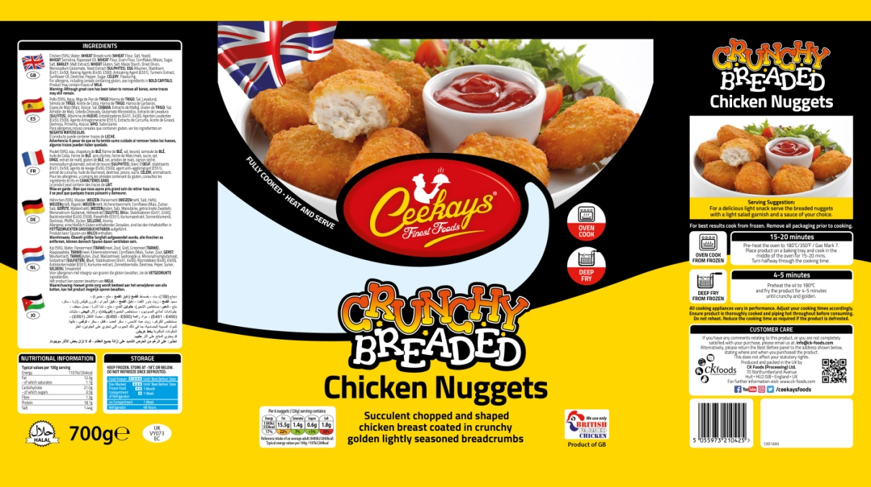
Ingredients and allergen information

Cooking Instructions

Storage Information

Supplier address

Barcode

Product name
Nutritional Information
Halal

Pack weight

Health mark

Product Code

Production Details

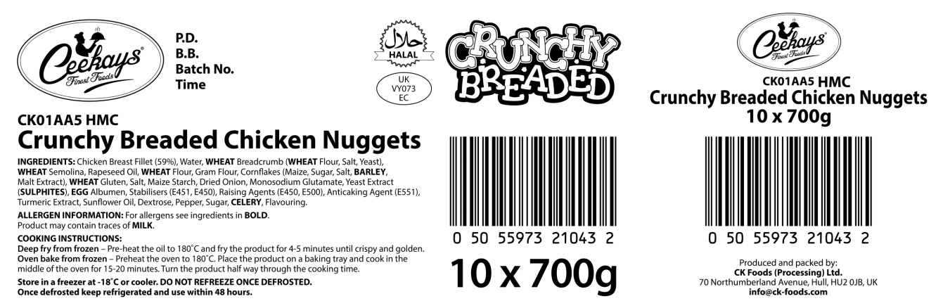

Product name

Ingredients and allergen information

Health mark

Barcode

Box quantity and pack size

STORAGE INSTRUCTIONS
Store frozen at temperature -18ᵒC or below. Do not refreeze once defrosted. Once defrosted keep refrigerated and use within 48 hours

PRODUCT SHELF-LIFE
18 months from the date of manufacturing (frozen)
COOKING INSTRUCTIONS
Deep fry from frozen – Pre-heat the oil to 180ᵒC and fry the product for 4-5 minutes until crispy and golden
Oven bake from frozen – Preheat the oven to 180ᵒC/350°F/Gas mark 7. Place the product on baking tray & cook in the middle of the oven for 15-20 minutes. Turn the product half way through the cooking time.
ALLERGEN INFORMATION
Egg | Yes | Milk | NO | Sesame seed | Absent
Celery | Yes | Mustard | Absent | Fish | Absent
Soya | Absent | Nuts | Absent | Molluscs | Absent
Gluten | Yes | Crustaceans | Absent | Lupin | Absent
Sulphur dioxide and sulphite | Yes | Peanuts | Absent
MAY CONTAIN MILK.
HACCP
There is a documented HACCP system in place at the site which is fully implemented to ensure that potential food safety risks are minimised. The HACCP system includes the analysis of chemical, physical, microbiological and allergenic risks from raw material procurement through the whole process to dispatch to the customer.
PALLET CONFIGURATION
Pallet configuration
90 boxes/pallet | 10 boxes/layer | 9 layers
DIETARY
Lacto-Ovo- Vegetarian | Vegan | Halal
NO | NO | YES (HMC)

ORGANOLEPTIC CHARACTERISTICS
Colour and Appearance: Golden yellow
Taste and Flavour: Succulent chicken breast coated in crispy golden breadcrumbs

*Private and confidential
**Specifications are subject to change
Authorised by (print) | Omar Bhamji |  | Approved by (print)
Sign  (Managing Director  CK Foods Processing Ltd) |  |  | Sign
 |  |  | For company
Date | 25/06/2019 |  | Date

