PRODUCT DETAILS
Product Code: | CK06C5
Customer Product Name: | Chef’s Classic Crispy Battered Chicken Steaks
Supplier Product Name: | Chef’s Classic Crispy Battered Chicken Steaks
Brand: | Ceekays
Issue Number: | 1
Issue Date: | 03/06/2020
Approved Date:

SUPPLIER DETAILS
Contact Address (Legal Entity) |  | Manufacturing Address: (if different)
Supplier Name: | CK Foods  (Processing)Ltd | Supplier Name: | CK Foods  (Processing)Ltd
Contact Name: | Aref Vacchiat | Contact Name : | Aref Vacchiat
Address: | 70 Northumberland Avenue  Hull  East Yorkshire | Address: | St Dunstans Way  West Bowling  Bradford  West Yorkshire
Postcode: | HU2 0JB | Postcode: | BD4 7EG
Telephone: | 0044(0)7912623741 | Telephone: | 0044(0)7912623741
Fax: |  | Fax: | 0044(0)1482 222776
 |  | Email Address for Specification Approval
 |  | Email: | technical@ck-foods.com

PRODUCT DESCRIPTION
(A secondary legal description of the product)
Succulent chopped and shaped chicken breast steaks coated in a crispy golden batter

PACKAGING DESCRIPTION
Av. Piece Wt (g): | 84.5 | Outer Case Gross Wt (kg) : | 6.413
No. of Pieces (Per Inner Film): | 12 | Outer Case Net Wt (kg) : | 0.293
Pack Size: | 6 x 1.02kg | Outer Cases Per Layer: | 10
Inners Per Case: | 6 | Layers Per Pallet: | 9
Outer Cases Per Pallet: | 90 | Inners Per Pallet: | 540
Count/Wt Per Inner: | 1.02 kg | Pallet Type & Dimensions (L x W x H)(mm): | Blue  1200 x 1000 x 162
Pallet Height with 80 Cases (mm): | 1908

3.0 Hazard Analysis Critical Control Points
An explanation of the manufacturing process in the structure of a flow diagram. All stages from the receipt of raw materials to the packing and storage of the finished product are included.
There is a documented HACCP system in place at the site which is fully implemented to ensure that potential food safety risks are minimised. The HACCP system includes the analysis of chemical, physical, microbiological and allergenic risks from raw material procurement through the whole process to dispatch to the customer.

4.0 RAW INGREDIENTS AND MATERIALS
Ingredients listed in descending order of weight (%), as resolved at the ‘mixing bowl’ stage of production. An explanation of sub-recipes and compound ingredients are provided where needed.

RAW INGREDIENT/MATERIAL | SUB COMPONENTS INCLUDING ALL ADDITIVES | % | SUPPLIER | COUNTRY OF ORIGIN
100% Chicken Breast Fillets | None | 53.5 | Gafoor Pure Halal | UK
Tempura (TE56330AB) | Wheat Flour, Maize Flour, Starch, Salt, Raising Agents: E450, E500, Pepper, Modified Starch, Dextrose, Water | 33.23 | Bowmans Ingredients | UK
Postcook Predust (PD38461AB) | Wheat Semolina, Wheat Gluten, Egg Albumen, Pepper, Rapeseed oil, Salt, Raising Agent: E450, E500, Celery, Sugar, Flavouring, Anticaking Agent: E551. | 3.07 | Bowmans Ingredients | UK
Rapeseed Oil | 100% Rapeseed Oil | 3 | KTC | UK, France, Germany, Hungary, Slovakia, Poland, Czech Republic, Belgium, Austria, Russia, Ukraine, Australia and Denmark
Precook predust (PD38453AB) | Wheat Semolina, Wheat Gluten, Egg Albumen, Salt, Rapeseed oil | 2.12 | Bowmans Ingredients | UK
Revo Starch (CKFRSP) | Rice flour and Modified starch | 0.60 | Dalziel Ingredients | UK, Germany, Belgium, Spain, Italy, France, India
Flavour Pack (CKFCNFP) | Dried onion, Yeast extract (Sulphite), Dextrose, Salt and Sugar | 0.53 | Dalziel Ingredients | UK, Germany, Belgium, Spain, Italy, France, India
Revo Brine (DMRB2) | Salt, Modified starch, Acidity regulator (E500), Flavouring agent | 0.30 | Dalziel Ingredients | UK, Holland
Phosphate (CKFPB) | Salt, Stabilisers (E451,E450) | 0.26 | Dalesman | UK, Izrael, Czech Republic, Germany
MSG | NONE | 0.11 | Ajinomoto | France

FOOD ADDITIVES/ PROCESSING AIDS
Declaration of all additives present including those which will not appear on the label (i.e. processing aid packing gases, and carry over additives from processing ingredients). THERE SHOULD BE NO BLANKS, IF THERES NO RESPONSE STATE “NONE”. If the ingredient has no technical function in the final product please explain the basis of this declaration and any effects that the additive has in the final product. If the ingredient has no effect in the final product state: “no effect in the final product” and therefore should not appear in the label).

E NUMBER | NAME | IN WHICH INGREDIENT OR COMPONENT | FUNCTION IN INGREDIENT | FINAL FUNCTION | QUANTITY IN INGREDIENT (STATE UNITS) | QUANTITY IN FINAL PRODUCT (USE SAME UNITS)
E450  &  E500 | Potassium and sodium di-phosphates  Sodium bicarbonate (Baking Soda) | Tempura (TE56330AB)  Postcook Predust (PD38461AB) | Raising Agent | None | 0.40g  0.01g | 0.41g
E500 | Sodium Bicarbonate (Baking Soda) | Revo Brine | Acidity regulator | None | 0.06g | 0.06g
E551 | Sodium Aluminosilicate | Postcook Predust (PD38461AB) | Anticaking Agent | None | 0.01g | 0.01g
E451  &  E450 | Potassium and sodium di-phosphates  Penta sodium tri phosphate | Phosphate  (CKFPB) | Stabiliser | None | 0.08g | 0.08g
E621 | Monosodium Glutamate | MSG | Flavour Enhancer | Flavour Enhancer | 0.11g | 0.11g

INGREDIENTS DECLARATION
The full ingredients declaration as presented on the packaging (including the QUID declarations where appropriate). Any differences between this declaration and the recipe (such as the product being cooked), reasoning and/or calculations made need to be shown. All ingredients MUST initiate with a starting capital letter.
Chicken Breast Fillet (53.5)%, Water, WHEAT Flour, Maize Flour, WHEAT Semolina, Rapeseed Oil, WHEAT Gluten, Starch, Salt, Raising Agents (E450, E500), Rice Flour, Modified Starch, Dried onion, Dextrose, Yeast Extract (SULPHITE), Pepper, EGG Albumen, Stabilisers (E451, E450), Acidity regulator (E500), Natural Flavouring, Sugar, Flavouring, CELERY, Anticaking Agent (E551).
Allergen information is shown in BOLD CAPITALS.
Allergen Statement: | For allergens, including cereals containing gluten, see ingredients in BOLD CAPITALS

May Contain:
MILK

COOKING INSTRUCTIONS
The suggested cooking instructions from frozen or defrost as suitable for Deep Fry/Oven/Grill/Boil/Microwave etc. Times and temperatures will be stated.
Microwave (Wattage stated): | N/A
Oven Bake From Frozen: | Pre-heat the oven to 180°C. Place the product on baking tray and cook in the middle of the oven for 25-30 minutes. Turn the product half way through the cooking time.
Deep Fry From Frozen: | Pre-heat the oil to 180°C and fry the product for 7-8 minutes until crispy and golden
Grill: | N/A
Other Cooking or Serving Instructions: | Check food is cooked thoroughly and is piping hot throughout before serving. Do not reheat.
Is this item suitable for storage as ambient: No

PHYSICAL/ORGANOLEPTIC PROPERTIES
Recordings of the essential physical/organoleptic/visual characteristics or dimensions of the product. Incorporate any inherent product defects. Any additional Information and images can be presented as appropriate.
 | As Supplied | When prepared in accordance to the instructions (see section 9)
Dimensions: | N/A | N/A
Aroma: | N/A | Savoury chicken aroma with no off or rancid taints
Visual Appearance: | White battered steaks | Golden Yellow battered coating
Flavour: | N/A | Succulent chicken breast coated in crispy golden batter
Texture: | Frozen | Crispy crunchy batter coating and succulent chicken

FINISHED PRODUCT – PHYSICAL STANDARDS
ARE INGREDIENTS SEIVED PRIOR TO USE? YES  Sieving is carried out in the Low Risk Area and High Risk Area for ingredients stored in all bags which are not of the ‘easy open’ design. |  |  | ARE ALL FINISHED PRPODUCTS METAL DETECTED? YES
 | SIEVE SIZES (mm) | FREQUENCY |  | TEST PIECE SIZES (mm) | FREQUENCY
Non-allergen ingredients (meat prep area) | 6 | Pour the ingredient into the sieve container and gently shake the whole sieve unit until all of the ingredient has passed through the sieve mesh.  Tailings Inspection  After all ingredients have been filtered through the sieve, inspect the sieve for presence of any packaging foreign bodies i.e. plastic. Non-allergen Sieve – ORANGE in colour. | FERROUS | 2 | At the start and end of shift, change of product or at least every hour.
Allergen ingredients (meat prep area) | 6 | Pour the ingredient into the sieve container and gently shake the whole sieve unit until all of the ingredient has passed through the sieve mesh.  Tailings Inspection  After all ingredients have been filtered through the sieve, inspect the sieve for presence of any packaging foreign bodies i.e. plastic. Allergen Sieve – YELLOW in colour  Use safety knife to open bag – detailed within De-boxing and De-bagging Procedure. | NON FERROUS | 2 | At the start and end of shift, change of product or at least Every hour.
Oven area (2mm) | 2 | Pour the ingredient into the sieve container and gently shake the whole sieve unit until all of the ingredient has passed through the sieve mesh.  Tailings Inspection  After all ingredients have been filtered through the sieve, inspect the sieve for presence of any packaging foreign bodies i.e. plastic. | STAINLESS STEEL | 2.5 | At the start and end of shift, change of product or at least every hour.
Oven area (2mm) | 2 | Pour the ingredient into the sieve container and gently shake the whole sieve unit until all of the ingredient has passed through the sieve mesh.  Tailings Inspection  After all ingredients have been filtered through the sieve, inspect the sieve for presence of any packaging foreign bodies i.e. plastic.

FINISHED PRODUCT - MICROBIOLOGICAL STANDARDS
A record of the microbiological standards for the product. All organisms which are appropriate to the product with included frequency of testing are presented.

ORGANISM | TARGET | MAXIUM
TVC | < 10000 | <1 x 10⁵
Salmonella | Absent in 25g | None
Campylobacter | Absent in 25g | None
Listeria Spp | Absent in 25g | None

FINISHED PRODUCT – ANALYTICAL STANDARDS
(This section is designed to record any legal and / or compositional standards, which apply to the product. e.g. meat content, glaze level, salt content / physical shrinkage / weight loss on cooking etc. Nutritional information is given in another section)

Test | Frequency | Target | Range
FFA (Frying Oil) | Daily (After Production) | 0-18%TPM | PASS = 0 – 24%TPM
Weight | Forming Weight  After Precook Predust  After Oven Bake  After Postcook Predust  After Tempura Coating  After Frying  Weight After Freezer | 55.7g  57.3g  57.6g  60g  88.5g  87.5g  84.5g | 55.5-56g  57-58g  56.6-58.6g  59-61g  87.5-89.5g  86-89g  82.5-86.5g

NUTRITIONAL INFORMATION
The nutritional information and indicate how it has been assessed e.g. as Sold, Raw, Cooked
COMPONENT | PER 100G/100ML | PER 1 STEAK/ 85G Serving
ENERGY KJ | 810 | 688.5
ENERGY Kcal | 194 | 164.9
PROTEIN (g) | 13.3 | 11.31
CARBOHDRATE (g) | 14.0 | 11.9
of which sugars (g) | 0.4 | 0.34
FAT (g) | 9.5 | 8.06
of which saturates (g) | 1.2 | 1.02
FIBRE (g) | 0.6 | 0.51
Expressed in salt (g) | 0.81 | 0.70

LABEL SPECIFICATIONS – PACKAGING
A list of information that will appear on the product label or print. The label must comply with BFFF standards
PRODUCT SIZE:  (Weight of product/number of units must be included) | 6 x 1.02kg
DURABILITY DATE (LOCATION & FORMAT)  (Provide an example use for ‘best before’ and batch codes for the inner pack. Sufficient information should be supplied in order for the batch code  to be interpreted). | BB date i.e. DD/MM/YY  PD date i.e. DD/MM/YY  Batch code i.e. Julian Code
INGREDIENTS AS DECLARED:  (All ingredients affected by the QUID calculation (Quantity Ingredients Declaration), with all GM ingredients mentioned where appropriate). | Chicken Breast Fillet (53.5%)
SPECIFY COUNTRY(S) OF MEAT ORGIN: | UK
STORAGE INSTRUCTIONS:  (Recommended storage and total product life span from production) | Store frozen at temperature ≤ -18ᵒC  Do not refreeze once defrosted.  Once defrosted keep refrigerated and use within 48 hours.  18 months from the date of manufacturing (frozen)
LABEL CLAIMS:  (Include details of any claims made on the packaging i.e. MAP, Nutritional Claims, Organic, Vegetarian, Low Fat etc). | British
COVERING REGULATIONS FOR LABEL:  (Health mark number if required) | UK VY073
CONDITIONS OF USE:  (Any warnings, any preparations for use i.e. cooking etc). | Oven bake from frozen – Preheat the oven to 180ᵒC. Place the product on baking tray and cook in the middle of the oven for 25-30 minutes. Turn the product half way through the cooking time.  Deep Fry Frozen - Pre-heat the oil to 180°C and fry the product for 7-8 minutes until crispy and golden  WARNING: Although great care has been taken to remove all bones, some trace may still remain.
BARCODE: | Inner Unit: 5055973211187  Outer Unit: 05055973211194
LABEL SIZE: | 230mm x 418mm
NUMBER OF LABELS PER CASE: | 1
LABEL POSITION: | Case end and long side
DOES THE ITEM COMPLY WITH BFFF PACKAGING GUIDELINES? | Yes
Production Details  Product name | Product code
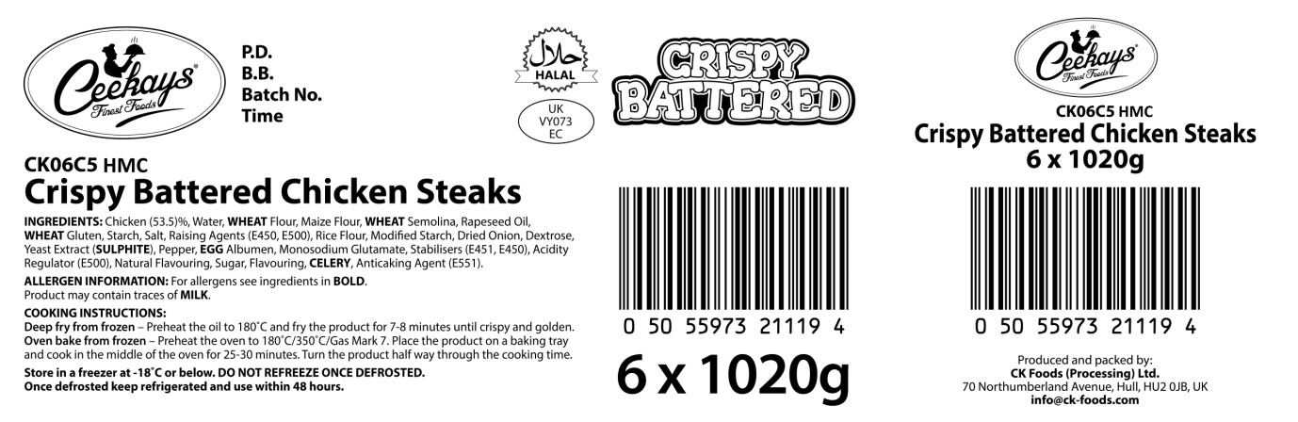
Barcode
Box quantity and pack size
Health mark
Ingredients and allergen information

PACKAGING – INNER SPECIFICATION
Is the inner packaging printed? | No
Dimensions of Inner Bag (mm) | 320mm x 300mm x 45mm
Colour of Inner Bag (if applicable) | Clear
Closure Type of Inner Bag (if applicable) | Heat Sealed
Are the inners given a durability and traceability code? (state position) | Yes, BOP (Bottom left)
Does the inner contain units that can be sold separately? | No

Product Image
Ingredients
Cooking instructions
Storage Information
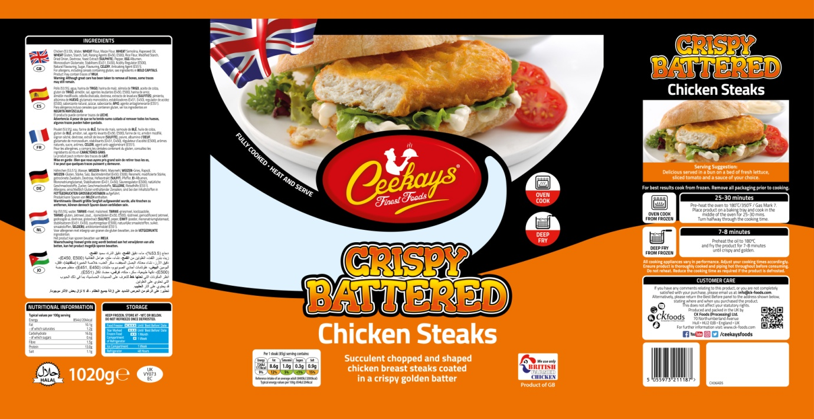
Supplier address
Barcode
Product name
Nutritional Information
Health mark
Halal
Pack weight

17 PACKAGING – OUTER /CASE SPECIFICATION
Is the case printed? | NO
If yes, is it suitable for sale as a traded unit either on its own or in combination with label (s)? (i.e. has all the information to comply with the current labelling regulations)
Does the outer contain units that can be sold separately? (i.e. has all the information to comply with the current labelling regulations) | No
Dimensions of Outer Case (External) (L x W x H in mm) | 384mm x 249mm x 194mm
Colours of Case | White
Board Grade/ Specifications (e.g. 125WT/B/125T) | C446W

PACKAGING – WEIGHTS APPROVED
(All food contact, non food contact, dividers, liners, pallet wrap etc, specify total in the saleable unit. For example, a case contains 8 bags of 400g each, must be stated as a single figure, for example 3200 and not 8x400.)
 | INDIVIDUAL WEIGHT | TOTAL WEIGHT ON PALLET
PRIMARY PLASTIC (kg) – INNER BAG FILM | 0.017 | 8.16
SECONDARY PLASTIC (kg) | N/A | N/A
TERTIARY PLASTIC (kg) | N/A | N/A
PRIMARY BOARD (kg) | N/A | N/A
SECONDARY BOARD (kg) – OUTER CASE | 0.293 | 23.44
TERTIARY BOARD (kg) | N/A | N/A
FOIL/ALUMINIUM (kg) | N/A | N/A
WOOD (kg) - PALLET | 28 | 28

SPECIAL DIETARY INFORMATION
It is essential to be thorough when completing this section, especially when taking into account any compound ingredients. The sources should also be recorded alongside all allergens/requirements present in the product. Any cross contamination from another product/process/environment must be taken into account. Environmental allergens that legally may need to be identified to the consumer need risk assessments to be carried out.

Does the Product Contain?
Wheat & Wheat Derivatives | Yes | Tempura (TE56330AB) | Recipe
Gluten containing Barley / Rye / Oats / Malt | No
Gluten as Additional Ingredient | No
Soya / Soya Derivatives | No
Genetically Modified Soya / Soya Derivatives | No
Maize & Maize Derivatives | Yes | Tempura (TE56330AB) | Recipe
Genetically Modified Maize / Maize Derivatives | No
Milk / Dairy Products | No
Egg / Egg Products | Yes | Postcook Predust (PD38461 AB)  Precook Predust (PD38453AB) | Recipe
Fish / Fish Products | No
Peanuts / Peanut Oils | No
Other Nuts / Nut Oils | No
Other Nuts Used on Site | No
Mustard / Mustard Derivatives | No
Celery / Celeriac Derivatives | Yes | Postcook Predust (PD38461 AB) | Recipe
Sulphites / Sulphur Dioxide >10ppm | Yes | Flavour Pack | Recipe
Sesame Seeds/Sesame seed derivatives | No
Other Seeds & Oils | No
Material derived from genetically modified ingredients | No
Materials derived from Irradiated ingredients | No
Meat Only - Multi Species Processing Site | No
If the product is of animal origin or contains ingredients of animal origin, were the animals fed on feed or feed ingredients derived from a genetically modified source? | No
Beef / Beef Derivatives | No
Pork / Pork Derivatives | No
Lamb / Lamb Derivatives | No
Poultry / Poultry Derivatives | Yes | Chicken/ Chicken Skin | Recipe
MRM | No
Offal | No
Animal Rennet (from Cheese) | No
Artificial Colours | No
Artificial Colours – Azo Dyes | No
Artificial Preservatives | No
Artificial Flavours | No
Flavouring 4,5-epoxy dec-2(trans)-enal | No
Artificial Sweeteners | No
Added Monosodium Glutamate | Yes | MSG | Recipe
Added Salt | No
Hydrogenated Fats | No
Lupins, or Lupin derivative | No
Molluscs | No
Kiwi | No
Is the Product?
Fried During Manufacture | Yes
Suitable for Vegetarians | No
Suitable for Coeliacs | No
Halal Approved | Yes | HMC

ALLERGENS
Egg | Yes
Milk | No
Fish | No
Crustaceans - Crab | No
Crustaceans - Lobster | No
Crustaceans - Crayfish | No
Crustaceans - Shrimp | No
Crustaceans - Prawn | No
Molluscs - Mussels | No
Molluscs - Oysters | No
Molluscs - Squid | No
Peanuts | No
Tree nuts - Almonds | No
Tree nuts - Hazelnuts | No
Tree nuts - Walnuts | No
Tree nuts - Cashews | No
Tree nuts - Pecans | No
Tree nuts - Brazils | No
Tree nuts - Pistachios | No
Tree nuts - Macadamia | No
Tree nuts - Queensland nuts | No
Sesame seeds | No
Cereals containing gluten (or their hybridised strains) - Wheat | Yes
Cereals containing gluten (or their hybridised strains) - Rye | No
Cereals containing gluten (or their hybridised strains) - Barley | No
Cereals containing gluten (or their hybridised strains) - Oats | No
Cereals containing gluten (or their hybridised strains) - Spelt | No
Cereals containing gluten (or their hybridised strains) - Kamut | No
Soybeans | No
Celery and celeriac | Yes
Mustard | No
Lupin | No
Sulphites at concentration of ten parts per million | Yes

CHECKLIST
Tick if requested information is attached

INFORMATION |  | REASON NOT SUBMITTED
Inner Artwork (If Applicable)
Inner Bag, Tray or Carton
Inner Label (s)
Outer Label (s)
Outer Artwork (If Applicable)
Outer Case

ADDITIONAL INFORMATION
Provide or attach any other information which is deemed appropriate
Nutritional information artwork for ‘Typical; Values per 100g’

Authorised by (print) | Omar Bhamji |  | Approved by (print)
Sign  (Managing Director  CK Foods Processing Ltd) (For pages 1-16) |  |  | Sign (For pages 1-16)
 |  |  | For company
Date | 15/04/2019 |  | Date

