PRODUCT INFORMATION
Product Name: Southern Fried Breaded Mini Fillets (45-55g) 12x500g
Description: Succulent chicken breast mini fillets coated in southern-style breadcrumbs
NAME AND ADDRESS OF PROCESSOR
Name: CK Foods (Processing) Ltd
Health Mark: UK VY073 EC
Address: St. Dunstans Way, off Ripley Street, West Bowling, Bradford, West Yorkshire, BD4 7HH, UK
Contact: CK Foods (Processing) Ltd.
70 Northumberland Avenue
Hull, East Yorkshire HU2 0JB
England, UK
Tel: 0044 (0)1482 589961
Fax: 0044 (0)1482 222776 Email: info@ck-foods.com
INGREDIENTS
Chicken Breast Fillet (57%), WHEAT Flour, Water, WHEAT Semolina, Rapeseed Oil, WHEAT Gluten, Salt, Starch, Sunflower Oil, Modified Waxy Maize Starch, Pepper, Flavour Enhancer (E621),Dried Yeast, Anticaking Agent (E551), Raising Agents: E450(i), E500(ii),Turmeric Extract, Colour: Paprika Extract and Flavouring (E160c), Dextrose, Acidity Regulator (E500), Onion Powder, EGG Albumen, Flavourings, Yeast Extract (SULPHITE), Paprika Extract, Fennel, Nutmeg, Garlic Powder, Herb Extract, Spice Extracts, Dried Glucose Syrup, Herb.
Allergen information is shown in BOLD CAPITALS.
WARNING: ALTHOUGH GREAT CARE HAS BEEN TAKEN TO REMOVE ALL BONES, SOME TRACES MAY STILL REMAIN.
NUTRITIONAL INFORMATION
 | Typical values per 100g | Typical values per serving - 3 Mini fillets (150g)
Energy | 1130KJ/270Kcal | 1695KJ/405Kcal
Fat | 12.2g | 18.3g
-of which saturates | 0.9g | 1.35g
Carbohydrates | 19.1g | 28.65g
-of which sugars | 0.3g | 0.45g
Fibre | 2.0g | 3g
Protein | 21.8g | 32.7g
Salt | 1.5g | 2.25g

PER 3 MINI FILLETS (150g) SERVING CONTAINS:
ENERGY (KJ/Kcal)  1695KJ/405Kcal  20% | Fat  18.3g  26% | Saturates  1.35g  7% | Sugars  0.45g  <1% | Salt  2.91g  49%

PACKAGING DETAILS

Pack size | Type | Pallet configuration |  |  | Box dimension (L x W x H) | Bag Dimension (H x W) | Labelling | Bag barcode | Box barcode
12 x 500g | HMC | 90 boxes/pallet | 10 boxes/ layer | 9 layers | 287mm x 240mm  x 134mm | 240mm x 270 mm | Printed Bag with Production, Best Before dates, batch and time thermal printed on rear. | 5055973211330 | 05055973211347
Bag label
Product Image
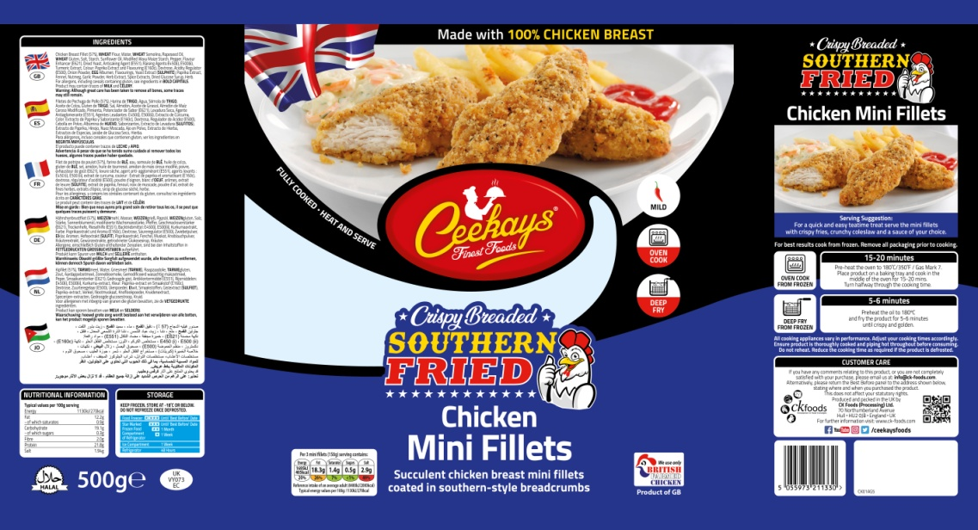
Ingredients

Cooking Instructions
Storage Information
Supplier address

Halal

Barcode
Product name
Nutritional Information
Health mark
Pack weight

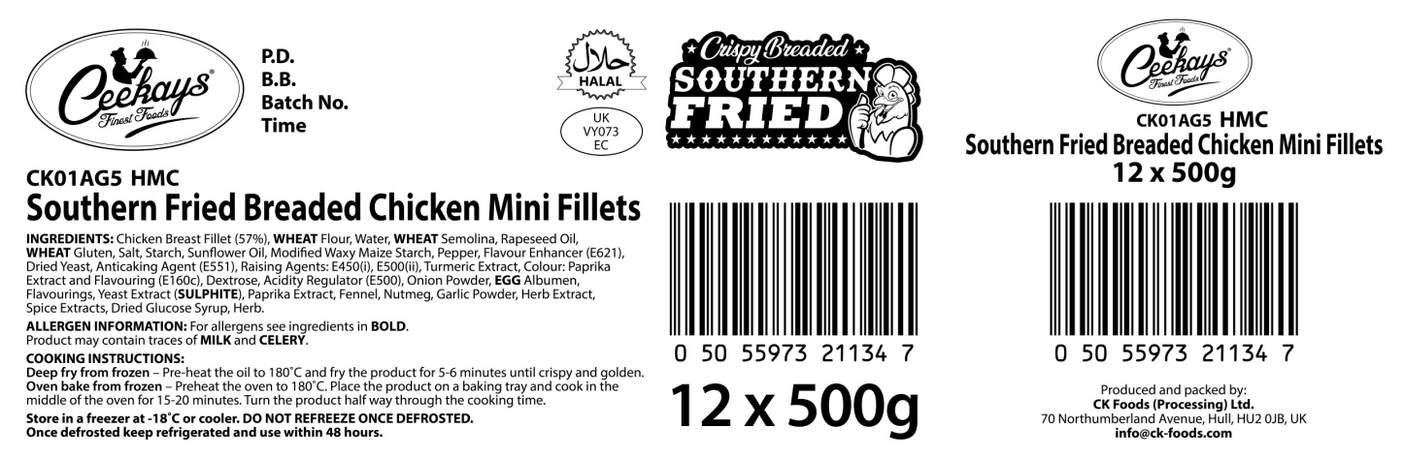
Product code
Production details

Product name

Ingredients and allergen information

Barcode
Box quantity and pack size
Health mark

STORAGE INSTRUCTIONS
Store frozen at temperature ≤ -18ᵒC
Do not refreeze once defrosted.
PRODUCT SHELF-LIFE
18 months from the date of manufacturing (frozen)
COOKING INSTRUCTIONS
Deep fry from frozen – Pre-heat the oil to 180ᵒC and fry the product for 5-6 minutes until crispy and golden
Oven bake from frozen – Preheat the oven to 180ᵒC. Place the product on baking tray and cook in the middle of the oven for 15-20 minutes. Turn the product half way through the cooking time.
ALLERGEN INFORMATION
Egg | Yes | Milk | NO | Sesame seed | Absent
Celery | NO | Mustard | Absent | Fish | Absent
Soya | Absent | Nuts | Absent | Molluscs | Absent
Gluten | Yes | Crustaceans | Absent | Lupin | Absent
Sulphur dioxide and sulphite | Yes | Peanuts | Absent

IMPORTANT: MAY CONTAIN MILK AND CELERY.

HACCP
There is a documented HACCP system in place at the site which is fully implemented to ensure that potential food safety risks are minimised. The HACCP system includes the analysis of chemical, physical, microbiological and allergenic risks from raw material procurement through the whole process to dispatch to the customer.
DIETARY
Lacto-ovo-vegetarian: NO
Vegan: NO
ORGANOLEPTIC CHARACTERISTICS
Colour and Appearance: Golden yellow with visual pepper
Taste and Flavour: Succulent chicken breast coated in southern fried coating.
*Private and confidential
**Specifications are subject to change
Authorised by (print) | Omar Bhamji |  | Approved by (print)
Sign  (Managing Director  CK Foods Processing Ltd) |  |  | Sign
 |  |  | For company
Date | 15/11/2018 |  | Date

