PRODUCT INFORMATION
Product Name: Hot'n'Spicy Breaded Chicken Mini Fillets (45-55g) 6X500g
Description: Breadcrumb coated chicken breast mini fillets with seasoned aromatic spices and a chilli kick
NAME AND ADDRESS OF PROCESSOR
Name: CK Foods (Processing) Ltd
Health Mark: UK VY073 EC
Address: St. Dunstans Way, off Ripley Street, West Bowling, Bradford, West Yorkshire, BD4 7HH, UK
Contact: CK Foods (Processing) Ltd.
70 Northumberland Avenue
Hull, East Yorkshire HU2 0JB
England, UK
Tel: 0044 (0)1482 589961
Fax: 0044 (0)1482 222776 Email: info@ck-foods.com
INGREDIENTS
Chicken Breast Fillet (58%), WHEAT flour, water, rapeseed oil, salt, Maize Starch, Durum WHEAT semolina, flavour enhancer (E621), Sunflower Oil, WHEAT gluten, Potato Starch, garlic powder, stabilisers (E451), Raising Agent (E450i)(E500ii), Anticaking Agent, black pepper, Turmeric Extract, paprika extract, Colour: Paprika Extract and Flavouring, spices (Chilli Powder, Cayenne, White Pepper, Black Pepper), onion powder, Cayenne Chilli, white pepper, Paprika, capsicum extract, Black Pepper Extract, Thickener (E415), garlic extract.
Allergen information is shown in BOLD CAPITALS.
WARNING: ALTHOUGH GREAT CARE HAS BEEN TAKEN TO REMOVE ALL BONES, SOME TRACES MAY STILL REMAIN.
NUTRITIONAL INFORMATION
 | Typical values per 100g |  | Typical values per serving - 3 Mini fillets (150g)
Energy |  | 1034kj/247kcal | 1332kj/318kcal
Fat | 11.5 |  | 17.3
- of which saturates | 1.0 |  | 1.5
Carbohydrates / | 16.5 |  | 24.8
- of which sugars / | 0.7 |  | 1.05
Fibre | 2.1 |  | 3.2
Protein | 20.3 |  | 30.5
Salt | 2.01 |  | 3.02
NUTRITIONALS
PER 3 MINI FILLETS (150g) SERVING CONTAINS:

ENERGY (KJ/Kcal)  1332kj/318kcal  16 % | Fat  17.3g  25% | Saturates  1.5g  8% | Sugars  1.05g  1% | Salt  3.02g  50.3%

PACKAGING DETAILS
=

Pack size | Type | Pallet configuration |  |  | Box dimension (L x W x H) | Bag Dimension (H x W x D) | Labelling | Bag Label | Box barcode
6 x 500g | HMC | 165 boxes/pallet | 15 boxes/ layer | 11 layers | 288mm x 240mm x 142mm | 240mm x 235mm x 150mm | Printed bag, Inkjet details on to box label | 5055973210616 | 5055973211064

Product Image

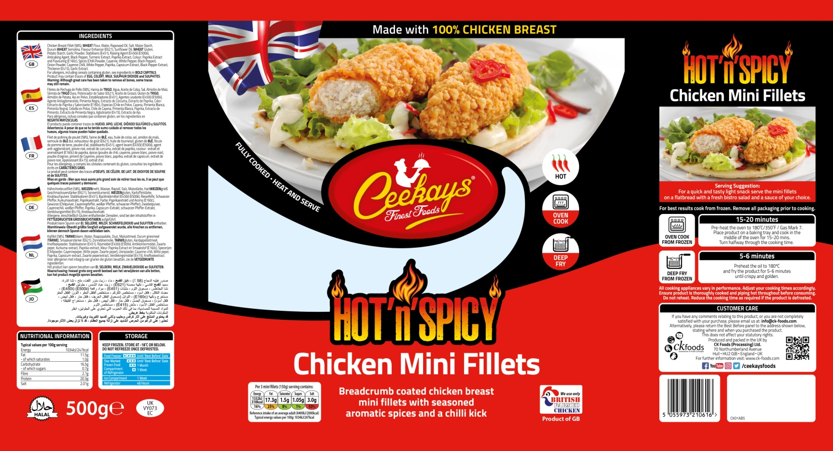

Ingredients

Storage Information

Cooking Instructions

Suppliers Address

Barcode
Product Name
Halal

Pack Size

Nutritional Information
Health mark

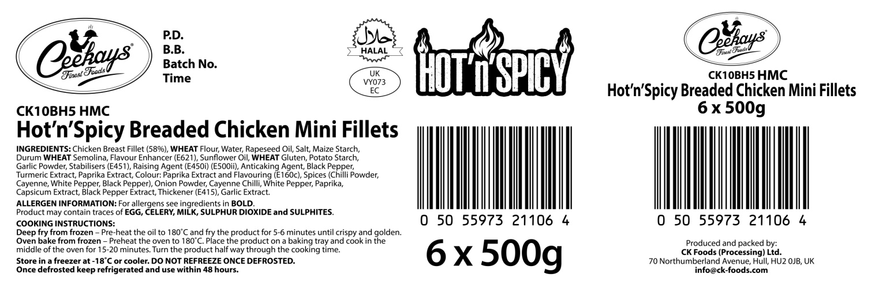

Production Details

Product Code

Product Name
Health Mark
Ingredients and Allergen Information

Barcode

Box quantity and pack size

STORAGE INSTRUCTIONS /
Store frozen at temperature ≤ -18ᵒC
Do not refreeze once defrosted.
Product Shelf-life: 18 months from the date of manufacturing (frozen).
COOKING INSTRUCTIONS
Deep fry from frozen – Pre-heat the oil to 180ᵒC/350⁰F and fry the product for 5-6 minutes until crispy and golden.
Oven bake from frozen – Preheat the oven to 180ᵒC/350⁰F. Place the product on baking tray and cook in the middle of the oven for 15-20 minutes. Turn the product half way through the cooking time.
ALLERGEN INFORMATION
Egg | No | Milk | No | Sesame seed | Absent
Celery | No | Mustard | Absent | Fish | Absent
Soya | Absent | Nuts | Absent | Molluscs | Absent
Gluten | Yes | Crustaceans | Absent | Lupin | Absent
Sulphur dioxide and sulphite | No | Peanuts | Absent
IMPORTANT: MAY CONTAIN EGG, CELERY, MILK AND SULPHITES.
HACCP
There is a documented HACCP system in place at the site which is fully implemented to ensure that potential food safety risks are minimised. The HACCP system includes the analysis of chemical, physical, microbiological and allergenic risks from raw material procurement through the whole process to dispatch to the customer.
DIETARY
Lacto-ovo-vegetarian: NO
Vegan: NO
ORGANOLEPTIC CHARACTERISTICS
Colour and Appearance: Deep orange in colour.
Taste and Flavour: Succulent chicken breast in a hot and spicy coating

*Private and confidential
**Specifications are subject to change
Authorised by (print) | Omar Bhamji |  | Approved by (print)
Sign  (Managing Director  CK Foods Processing Ltd) |  |  | Sign
 |  |  | For company
Date | 16/01/2020 |  | Date

