PRODUCT INFORMATION
Product Name: Peri Peri Breaded Chicken Bites
Description: Citrus Flavoured breadcrumb coated bite-size pieces of chicken breast with a subtle hint of heat.
NAME AND ADDRESS OF PROCESSOR
Name: CK Foods (Processing) Ltd
Health Mark: UK VY073 EC
Address: St. Dunstans Way, off Ripley Street, West Bowling, Bradford, West Yorkshire, BD4 7HH, UK
Contact: CK Foods (Processing) Ltd.
70 Northumberland Avenue
Hull, East Yorkshire HU2 0JB
England, UK
Tel: 0044 (0)1482 589961
Fax: 0044 (0)1482 222776 Email: info@ck-foods.com
INGREDIENTS
Chicken Breast Fillet (56%), Water, WHEAT Flour, Salt, WHEAT Semolina, Rapeseed Oil, Flavour Enhancer: E621, Maize Starch, WHEAT Starch, Wheat Gluten, Breadcrumb(WHEAT Flour, Yeast, Salt), Stabilisers (E451, E450, E407), Gram Flour, Flavouring, Lemon Oil, Maltodextrin, Capsicum Extract, Paprika Powder, Pepper, EGG Albumen, Cayenne Pepper, Raising Agents (E450(i), E500(ii)), Herb, Black Pepper Extract, Garlic Powder, Sodium Diacetate :E262, Coriander, Oregano, Citric Acid: E330, Anti-caking Agent: (E551), Colour: E100.
Allergen information is shown in BOLD CAPITALS.
WARNING: ALTHOUGH GREAT CARE HAS BEEN TAKEN TO REMOVE ALL BONES, SOME TRACES MAY STILL REMAIN.
NUTRITIONAL INFORMATION (As Fried)
 | Typical values per 100g | Typical values per serving (128g) - 8 per serving
Energy | 1092kj/260kcal | 1317KJ/333Kcal
Fat | 11.3g | 14.5g
-of which saturates | 1.0g | 1.3g
Carbohydrates | 19.8g | 25.3g
-of which sugars | 0.3g | 0.4g
Fibre | 2.1g | 2.7g
Protein | 21.0g | 26.9g
Salt | 3.59g | 4.60g
PER 8 MINI BITES (128g) SERVING CONTAINS:
ENERGY (KJ/Kcal)  1317KJ/333Kcal  16% | Fat  14.5g  21% | Saturates  1.3g  7% | Sugars  0.4g  <1% | Salt  4.60g  76.7%

Pack size | Type | Pallet configuration |  |  | Box dimension (L x W x H) | Bag Dimension (H x W x D) | Labelling | Bag barcode | Box barcode
6 x 500g | HMC | 165 boxes/  pallet | 15boxes/  layer | 11  layers | 288mm x 240mm  x 142mm | 240mm x 235mm x 150mm | Printed bag. Inkjet details on to box label | 5055973210593 | 5055973211040
PACKAGING DETAILSPPPP

Bag
Product Image

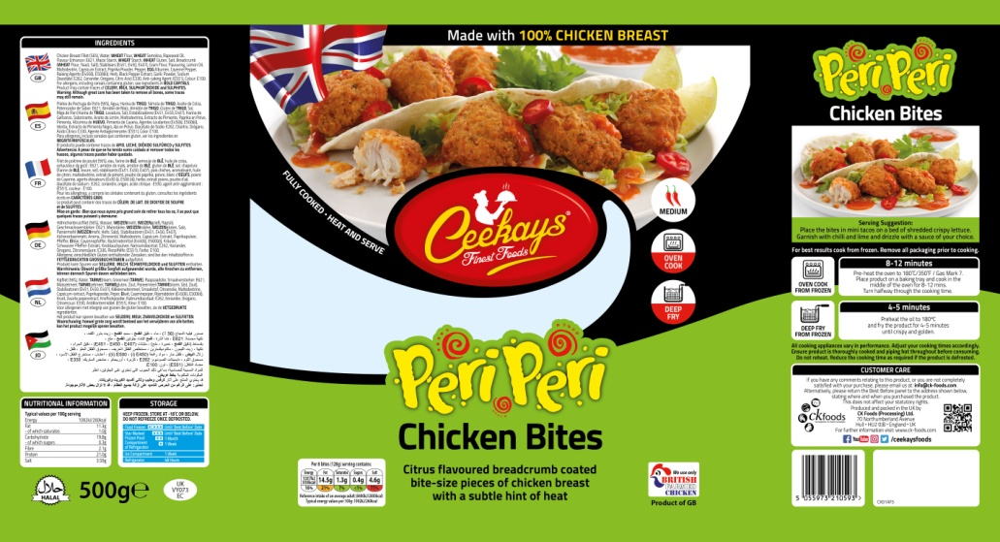
Ingredients

Cooking instructions
Storage Information

Supplier address

Halal
Pack size
Barcode
Product name
Nutritional information
Health mark

Box label

Product code
Product name
Production details
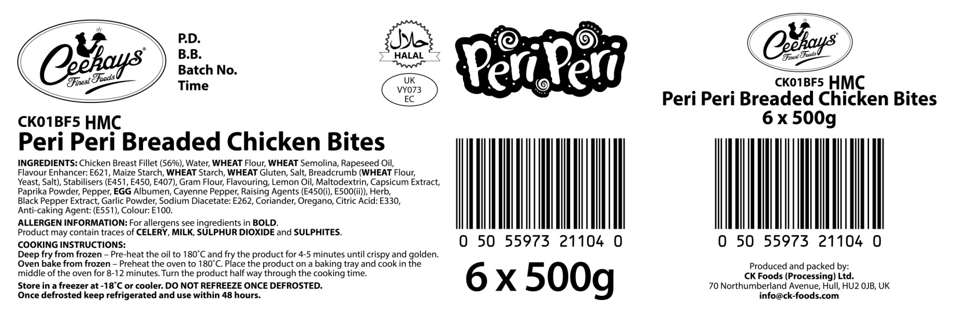
Barcode
Ingredients and allergen information
Health mark
Box quantity and pack size

STORAGE INSTRUCTIONS
Store frozen at temperature ≤ -18ᵒC
Do not refreeze once defrosted
PRODUCT SHELF-LIFE
18 months from the date of manufacturing (frozen)
COOKING INSTRUCTIONS
Deep fry from frozen – Pre-heat the oil to 180ᵒC/350°F and fry the product for 4-5 minutes until crispy and golden
Oven bake from frozen – Preheat the oven to 180ᵒC/350°F. Place the product on baking tray and cook in the middle of the oven for 8-12 minutes. Turn the product half way through the cooking time.

ALLERGEN INFORMATION
Egg | YES | Milk | NO | Sesame seed | Absent
Celery | No | Mustard | Absent | Fish | Absent
Soya | Absent | Nuts | Absent | Molluscs | Absent
Gluten | Yes | Crustaceans | Absent | Lupin | Absent
Sulphur dioxide and sulphite | No | Peanuts | Absent

IMPORTANT: MAY CONTAIN CELERY, MILK, SULPHUR DIOXIDE AND SULPHITES.
HACCP
There is a documented HACCP system in place at the site which is fully implemented to ensure that potential food safety risks are minimised. The HACCP system includes the analysis of chemical, physical, microbiological and allergenic risks from raw material procurement through the whole process to dispatch to the customer.
DIETARY
Lacto-ovo-vegetarian: NO
Vegan: NO
ORGANOLEPTIC CHARACTERISTICS
Colour and Appearance: Deep orange in colour
Taste and Flavour: Succulent chicken breast coated in crispy crunchy peri-peri coating

*Private and confidential
**Specifications are subject to change
Authorised by (print) | Omar Bhamji |  | Approved by (print)
Sign  (Managing Director  CK Foods Processing Ltd) |  |  | Sign
 |  |  | For company
Date | 07/01/2020 |  | Date

