PRODUCT INFORMATION
Product Name: Hot'n'Spicy Breaded Chicken Mini Fillets (45-55g) 12X500g
Description: Breadcrumb coated chicken breast mini fillets with seasoned aromatic spices and a chilli kick
NAME AND ADDRESS OF PROCESSOR
Name: CK Foods (Processing) Ltd
Health Mark: UK VY073
Address: St. Dunstans Way, off Ripley Street, West Bowling, Bradford, West Yorkshire, BD4 7HH, UK
Contact: CK Foods (Processing) Ltd.
70 Northumberland Avenue
Hull, East Yorkshire HU2 0JB
England, UK
Tel: 0044 (0)1482 589961
Fax: 0044 (0)1482 222776
Email: info@ck-foods.com
INGREDIENTS
Chicken Breast Fillets (58%), WHEAT Flour, Water, Rapeseed Oil, WHEAT Semolina, Salt, Sunflower Oil, WHEAT Gluten, Maize Starch, Monosodium Glutamate, Raising Agent (E450i)(E500ii), Potato Starch, Anticaking Agent, Garlic Powder, Black Pepper, Turmeric Extract, Stabilisers (E451), Colour: Paprika Extract and Flavouring, Paprika Extract, Spices (Chilli Powder, Cayenne, White Pepper, Black Pepper), Onion Powder, Cayenne Chilli, White Pepper, Paprika, EGG Albumen, Capsicum Extract, Black Pepper Extract, Thickener (E415), Garlic Extract.
For allergens, including cereals containing GLUTEN, see ingredients in BOLD CAPITALS.
WARNING: ALTHOUGH GREAT CARE HAS BEEN TAKEN TO REMOVE ALL BONES, SOME TRACES MAY STILL REMAIN.
NUTRITIONAL INFORMATION
 | Typical values per 100g |  | Typical values per serving - 3 Mini fillets (150g)
Energy |  | 1034kj/247kcal | 1332kj/318kcal
Fat | 11.5 |  | 17.3
- of which saturates | 1.0 |  | 1.5
Carbohydrates / | 16.5 |  | 24.8
- of which sugars / | 0.7 |  | 1.05
Fibre | 2.1 |  | 3.2
Protein | 20.3 |  | 30.5
Salt | 2.01 |  | 3.02
PER 3 MINI FILLETS (150g) SERVING CONTAINS:

ENERGY (KJ/Kcal)  1332kj/318kcal  16 % | Fat  17.3g  25% | Saturates  1.5g  8% | Sugars  1.05g  1% | Salt  3.02g  50.3%

PACKAGING DETAILS
=

Pack size | Batch Details | Box dimension (L x W x H) | Bag Dimension  (H x W x D) | Labelling | Product Code on the Bag | Bag barcode | Product Code on the Box | Box barcode
12 x 500g | PD: DD/MM/YYYY  BB: DD/MM/YYYY  BATCH CODE:  JULIAN CODE  TIME: HH:MM | 384mm x 249mm x 194mm | 240mm x 270mm x 45mm | Printed bag, Inkjet details on to box label. | CK01AB5 | 5055973210616 | CK01AB5 | 05055973210623

Product Image

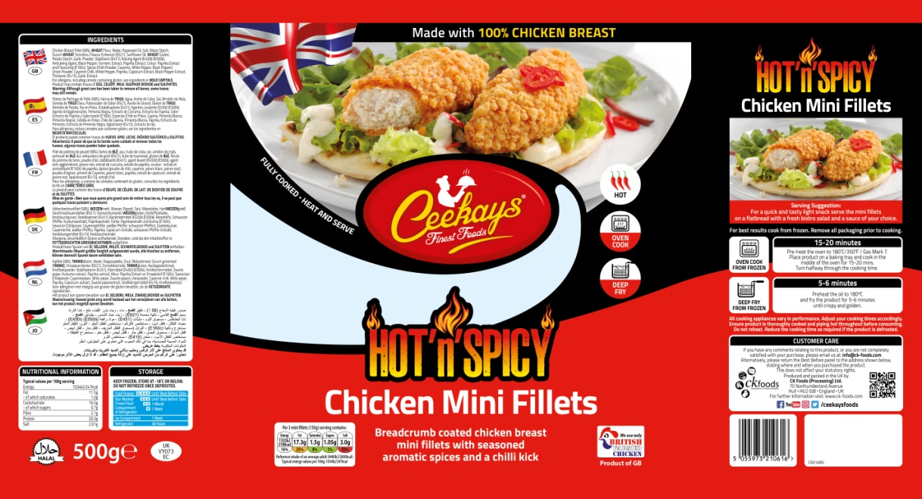

Ingredients

Cooking Instructions

Storage Instructions

Supplier Address

Halal

Barcode
Product Name
Nutritional Information
Health mark
Pack Size

STORAGE INSTRUCTIONS & PRODUCT SHELF LIFE
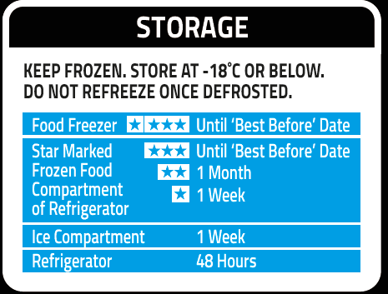
Once defrosted keep refrigerated and use within 48 hours
Product Shelf-life: 18 months from the date of manufacturing (frozen).
COOKING INSTRUCTIONS
For best results cook from frozen. Remove all packaging prior to cooking.

All cooking appliances vary in performance. Adjust your cooking times accordingly. Ensure product is thoroughly cooked and piping hot throughout before consuming. Do not reheat. Reduce the cooking time as required if the product is defrosted.

Deep fry from frozen – Pre-heat the oil to 180ᵒC/350⁰F and fry the product for 5-6 minutes until crispy and golden.
Oven bake from frozen – Preheat the oven to 180ᵒC/350°F/Gas mark 7. Place the product on baking tray and cook in the middle of the oven for 15-20 minutes. Turn the product half way through the cooking time.
ALLERGEN INFORMATION
Egg | YES | Milk | No | Sesame seed | Absent
Celery | No | Mustard | Absent | Fish | Absent
Soya | Absent | Nuts | Absent | Molluscs | Absent
Gluten | Yes | Crustaceans | Absent | Lupin | Absent
Sulphur dioxide and sulphite | No | Peanuts | Absent
IMPORTANT: MAY CONTAIN : CELERY, MILK, SULPHUR DIOXIDE AND SULPHITES.
HACCP
There is a documented HACCP system in place at the site which is fully implemented to ensure that potential food safety risks are minimised. The HACCP system includes the analysis of chemical, physical, microbiological and allergenic risks from raw material procurement through the whole process to dispatch to the customer.
PALLET CONFIGURATION
Pallet configuration
90 boxes/pallet | 10 boxes/layer | 9 layers
DIETARY
Lacto-Ovo- Vegetarian | Vegan | Halal
NO | NO | YES (HMC)
ORGANOLEPTIC CHARACTERISTICS
Colour and Appearance: Deep orange in colour.
Taste and Flavour: Succulent chicken breast with a crunchy breaded coating and seasoned aromatic spices with a chilli kick.
CUSTOMER CARE
If you have any comments relating to this product, or you are not completely satisfied with your purchase, please email us at: info@ck-foods.com. Alternatively, please return the Best Before panel to the address shown below, stating where and when you purchased the product. This does not affect your statutory rights. Produced and packed in the UK by CK Foods (Processing) Ltd., 70 Northumberland Avenue, Hull, HU2 0JB, England, UK. For further information visit: www.ck-foods.com.

*Private and confidential
**Specifications are subject to change
Authorised by (print) | Omar Bhamji |  | Approved by (print)
Sign  (Managing Director  CK Foods Processing Ltd) |  |  | Sign
 |  |  | For company
Date | 30/11/2020 |  | Date

