PRODUCT INFORMATION
Product Name: Southern Fried Breaded Drumsticks & Thighs 4x2kg
Description: Succulent chicken Drums and Thighs coated in southern fried coating
NAME AND ADDRESS OF PROCESSOR
Name: CK Foods (Processing) Ltd
Health Mark: UK VY073
Address: St. Dunstans Way, off Ripley Street, West Bowling, Bradford, West Yorkshire, BD4 7HH, UK
INGREDIENTS
Chicken 60%, Water, Wheat Flour, Wheat Semolina, Rusk (Made from Wheat Flour), Rapeseed Oil, Gram Flour, Wheat Gluten, Salt, Maize Starch, Pepper, Dried Onion, Yeast Extract (Sulphite), Spices (Black Pepper, White Pepper, Chilli Powder, Nutmeg, Cinnamon), Monosodium Glutamate, Stabilisers (E451, E500), Flavour Enhancer: E621, Dried Yeast, Egg Albumen, Raising Agents: E450(i) E500(ii), Anticaking Agent: E551, Turmeric Extract, Dextrose, Onion Powder, Garlic Powder, Raising Agents: E503, Sunflower Oil, Sugar, Natural Flavouring, Oregano, Spice Extracts ( Paprika, Black Pepper), Herb, Herb Extract (Celery).
Allergen information is shown in Bold.
NUTRITIONAL INFORMATION
 | Typical values per 100g | Typical values per serving - 150g portion
Energy | 879kJ/210kcal | 1318kJ/315kcal
Fat | 11.7g | 17.5g
-of which saturates | 2.1g | 3.1g
Carbohydrates | 11.5g | 17.2g
-of which sugars | 0.6g | 0.9g
Fibre | 1.3g | 1.9g
Protein | 15.5g | 23.2g
Salt | 0.9g | 1.35g

PACKAGING DETAILS
PPPP
Pack size | Type | Pallet configuration |  |  | Box dimension (L x W x H) | Bag Dimension (H x W x D) | Bag barcode | Box barcode
4 x 2kg | HMC | 70 boxes/pallet | 10 boxes/layer | 7 layers | 400mm x 265mm x 250mm | 320mm x 270mm x 70mm | 5055973206367 | 05055973206374

Bag label
Product Image

Ingredients
Cooking Instructions

Storage information
Nutritional Information

Supplier address
Barcode

Pack weight
Health mark
Product name

Box label

Production details
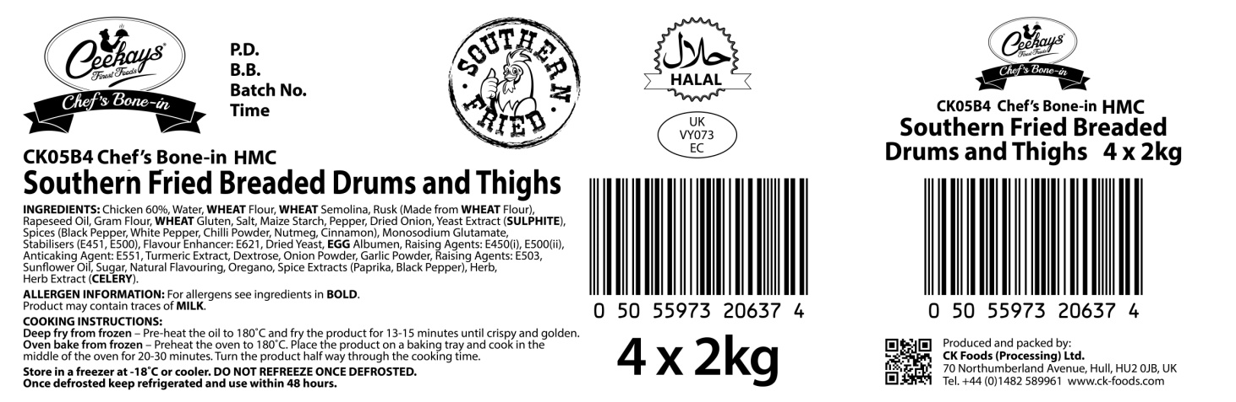
Product code
Product name

Ingredients and allergen information

Barcode
Health mark
Box quantity and pack size

STORAGE INSTRUCTIONS
Store in a freezer at -18ᵒC or cooler. DO NOT REFREEZE ONCE DEFROSTED. Once defrosted keep refrigerated and use within 48 hours.
PRODUCT SHELF-LIFE
18 months from the date of manufacturing (frozen)
COOKING INSTRUCTIONS
Deep fry from frozen – Pre-heat the oil to 180ᵒC and fry the product for 13-15 minutes until crispy and golden
Oven bake from frozen – Preheat the oven to 180ᵒC. Place the product on baking tray & cook in the middle of the oven for 20-30 minutes. Turn the product half way through the cooking time.
ALLERGEN INFORMATION
Egg | Yes | Milk | NO | Sesame seed | Absent
Celery | Yes | Mustard | Absent | Fish | Absent
Soya | No | Nuts | Absent | Molluscs | Absent
Gluten | Yes | Crustaceans | Absent | Lupin | Absent
Sulphur dioxide and sulphite | Yes | Peanuts | Absent

IMPORTANT: MAY CONTAIN MILK AND SOYA.

HACCP
There is a documented HACCP system in place at the site which is fully implemented to ensure that potential food safety risks are minimised. The HACCP system includes the analysis of chemical, physical, microbiological and allergenic risks from raw material procurement through the whole process to dispatch to the customer.
DIETARY
Lacto-ovo-vegetarian: NO
Vegan: NO
ORGANOLEPTIC CHARACTERISTICS
Colour & Appearance: Golden yellow with visual pepper
Taste & Flavour: Succulent chicken drums and thighs coated in southern fried coating

*Private and confidential
**Specifications are subject to change
Authorised by (print) | Omar Bhamji |  | Approved by (print)
Sign  (Managing Director  CK Foods Processing Ltd) |  |  | Sign
 |  |  | For company
Date | 06/11/2017 |  | Date

